Microk8s setup

# sudo snap install microk8s --classic

# microk8s status --wait-ready





Now install kubectl command lie tool

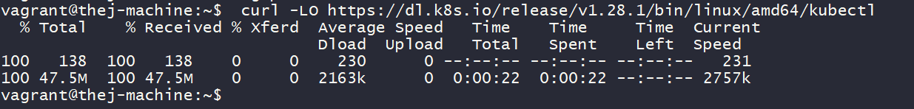





From above we are installed microk8s and kubectl they are different packages we eed to configure bothe of them to communicate

Kubectl command will communicate with microk8s



Restart the system now

Login to system now

